Setup proxmox

Server laptop: 8gb ram, dell latitude

During installation choose graphical > key in country name > connect to lan and assign an ip address (this can still be later edited in /etc/network/interfaces)> key in a password as well which will be used to login to both the web interface and your proxmox server itself.

Once installed access <https://server-ip:8006>

Proceed with the linux pam standard authentication

Ignore this and just click ok as we are doing homelab

Now expand the left panel and select local-lvm and as you can see here there are 300+gb of unused space

Click on Datacenter > Storage > local-lvm > remove

Select yes

Now click on your proxmox node and select shell

Run the command lvremove /dev/pve/data

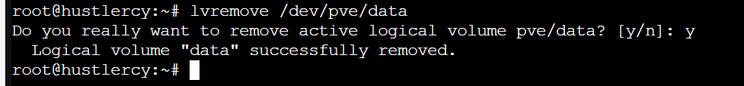

Now run the command lvresize -l +100%FREE /dev/pve/root

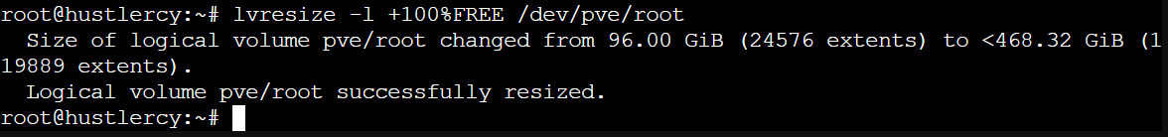

Lastly, run resize2fs /dev/mapper/pve-root

Now you should see the full space available

Also, if you click on your node again and click on updates you can see some packages available. You can click on upgrade to upgrade it

A separate window will open up can just press Y and let it run

